1066

The year was 1065 and in London the English king, Edward the Confessor, was dying. He had no children and three men claimed the throne of England: Harold Godwin, the Earl of Wessex, William, the Duke of Normandy and Harald Hardraada, the King of Norway.

Harold Godwin was the most important of the Anglo-Saxon lords. Edward had been a weak king and Harold had been the real ruler of England for many years. When Edward died at the end of 1065, Harold was crowned king.

When the news reached Duke William, he was very angry. William was the Duke of Normandy in northern France and he was Edward's cousin. Edward had grown up in Normandy and he had promised William the throne. Duke William was tall and strong and he was a famous soldier.

But if William was tall, Harald Hardraada was even taller. He was a giant, almost seven feet tall. Hardraada's ancestors had been kings of England before Edward and now he wanted the throne for himself.

The first challenge to King Harold Godwin came from the north. In 1066 at the end of the summer, Harald Hardraada landed in north-eastern England. Godwin inarched north with his army.

The Anglo-Saxon and Norwegian armies met at Stamford Bridge near the city of York. Before the battle, Hardraada asked King Harold: 'How much of England will you give me?' 'Seven feet, Godwin replied, enough for your grave.'

And that was all that Hardraada received. By the end of the day he was dead and the Norwegian army had been destroyed. But, while Harold and his soldiers were resting after the battle, news arrived from London: Duke William had landed on the south coast near the town of Hastings.

William stayed near Hastings and waited for Harold Godwin. The English king returned to London, collected a new army and marched to Hastings. They stopped on a hill and the battle began. The Anglo-Saxons fought on foot, but the Normans were on horses.

The Normans attacked but the Anglo-Saxon soldiers were safe on the top of the hill. They pushed the Normans back. Then the Normans pretended to run away. Some of the Anglo-Saxons chased them down the hill. But the Norman knights turned round and killed them.

Harold and most of his army had stayed on the hill. But then the Norman archers attacked. They fired their arrows into the air. King Harold looked up and an arrow hit him in the eye. The last Angle-Saxon king was and Duke William had won.

After the Battle of Hastings, William marched to London and was crowned king of England. He is now called William the Conqueror and 1066 is the most famous date in English history. It was a turning point for English history and the English language.
CULTURE SPOT

Invaders
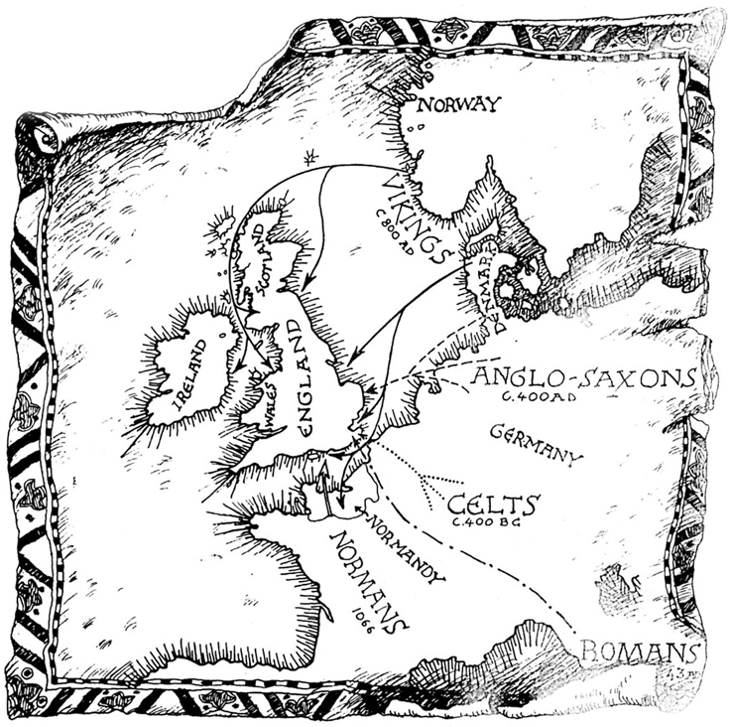
The Norman Conquest was the last successful attack on Britain, but in the centuries before 1066, different groups of people had invaded the British Isles.

In about 400 BC the Celts came to Britain. The Celts weren't the first people to come to Britain, but we don't know much about the earlier inhabitants.

In ad 43 the Romans conquered southern Britain. They didn't conquer Scotland. The Roman Emperor, Hadrian, built a wall to keep the wild Scottish tribes out. Hadrian's Wall was the northern limit of the Roman Empire.

The Romans stayed in Britain for over 300 years, but around ad 400 tribes from Germany started to attack the Empire. The Romans left Britain. People from Holland, Northern Germany and Denmark attacked and conquered England. These people are called Anglo-Saxons. The name England comes from 'Angle-land', The Anglo-Saxons pushed the Celts into Scotland, Wales and Ireland.

Four hundred years later, the Vikings attacked Britain. The Vikings came from Norway and Denmark. The English kings gave the Vikings the north-eastern half of England. The Vikings also attacked France. The French king gave them land, too. It was called 'the land of the Northman of Normandy'.

COMPARISON

• Where did your people come from?
• Did the Celts, Romans, German tribes or Vikings invade your country, too?

