Higher Education

Out of more than three million students who graduate from high school each year, about one million go on for higher education. A college at a leading university might receive applications from two percent of these high school graduates, and then accept only one out of every ten who apply. Successful applicants at such colleges are usually chosen on the basis of a) their high school records; b) recommendations from their high school teachers; c) their scores on the Scholastic Aptitude Tests (SATs).
The system of higher education in the United States comprises three categories of institutions: 1) the university, which may contain a) several colleges for undergraduate students seeking a bachelor's (four-year) degree and b) one or more graduate schools for those continuing in specialized studies beyond the bachelor's degree to obtain a master's or a doctoral degree, 2) the technical training institutions at which high school graduates may take courses ranging from six months to four years in duration and learn a wide variety of technical skills, from hair styling through business accounting to computer programming and 3) the two-year, or community college, from which students may enter many professions or may transfer to four-year colleges.
Any of these institutions, in any category, might be either public or private, depending on the source of its funding. Some universities and colleges have, over time, gained reputations for offering particularly challenging courses and for providing their students with a higher quality of education. The factors determining whether an institution is one of the best or one of the lower prestige are quality of the teaching faculty; quality of research facilities; amount of funding available for libraries, special programs, etc.; and the competence and number of applicants for admission, i.e. how selective the institution can be in choosing its students.
The most selective are the old private north-eastern universities, commonly known as the Ivy League, include Harvard Radcliffe, (Cambridge Mass., in the urban area of Boston), Yale University (New Haven, Conn. between Boston and New York), Columbia College (New York), Princeton University (New Jersey), Brown University, Cornell University, Dartmouth College; University of Pennsylvania. With their traditions and long established reputations they occupy a position in American university life rather like Oxford and Cambridge in England, particularly Harvard and Yale. The Ivy League Universities are famous for their graduate schools, which have become intellectual elite centers.
In defence of using the examinations as criteria for admission, administrators say that the SATs provide a fair way for deciding whom to admit when they have ten or twelve applicants for every first-year student seat.
In addition to learning about a college/university's entrance requirements and the fees, Americans must also know the following.
Professional degrees such as a Bachelor of Law (LL.A.) or a Bachelor of Divinity (B.D.) take additional three years of study and require first a B.A. or B.S. to be earned by a student.
Graduate schools in America award Master's and Doctor's degrees in both the arts and sciences. Tuition for these programs is high. The courses for most graduate degrees can be completed in two or four years. A thesis is required for a Master's degree; a Doctor's degree requires a minimum of two years of course work beyond the Master's degree level, success in a qualifying examination, proficiency in one or two foreign languages and/or in a research tool (such as statistics) and completion of a doctoral dissertation.
The number of credits awarded for each course relates to the number of hours of work involved. At the undergraduate level a student generally takes about five three-hour-a week courses every semester. (Semesters usually run from September to early January and late January to late May.) Credits are earned by attending lectures (or lab classes) and by successfully completing assignments (задания) and examinations. One credit usually equals one hour of class per week in a single course. A three-credit course in Linguistics, for example, could involve one hour of lectures plus two hours of seminars every week. Most students complete 10 courses per an academic year and it usually takes them four years to complete a bachelor's degree requirement of about 40 three-hour courses or 120 credits.
In the American higher education system credits for the academic work arc transferable among universities. A student can accumulate credits at one university, transfer them to a second and ultimately receive a degree from there or a third university.

ORGANIZATION AND STRUCTURE OF THE SYSTEM OF EDUCATION IN THE USA

The school year is usually nine months, from early September to mid-June. The common pattern of organization, referred to as the 6-3-3 plan, includes elementary school in grades 1 through 6, junior high school in grades 7 through 9 and senior high school in grades 10 through 12. The older 8-4 plan, however, in which grades 1 through 8 were the elementary school and 9 through 12 the high school, continues in many localities. There is also a 6-6 plan, grades 1 through 6 in elementary school and 7 through 12 in the secondary school. Today, unified systems operating both elementary and secondary schools most commonly use the 6-3-3 plan or a 6-2-4 variation. However, many variations on the patterns exist in the United States.
Preschool education: A child's introduction to formal education is usually in kindergarten classes operated in most public school systems. Many systems also provide nursery schools. The age group is commonly four and five years. These preschool education programs maintain a close relationship with the home and parents, and aim to give children useful experiences which will prepare them for elementary school. The programs are flexible and are designed to help the child grow in self-reliance уверенность в своих силах, learn to get along with others, and form good work and play habits.
Elementary school: The main purpose of the elementary school is the general intellectual and social development of the child from 6 to 12 or 15 years of age. Curricula учебный план vary with the organization and educational aims of individual schools and communities. The more or less traditional program consists of teaching prescribed subject matter. Promotion перевод from one grade to the next is based on the pupil's achievement of specified skills in reading, writing, spelling, arithmetic, history, geography, music and art.
Secondary school: Most pupils follow a course that includes English, science, social studies, mathematics and physical education. Elective subjects may be chosen in the fields of foreign languages, fine arts and vocational training профессионально-техническое образование. Pupils usually elect about half their work in grades nine through twelve.
Most young Americans graduate from school with a high school diploma upon satisfactory completion of a specified number of courses.
Students are usually graded ранжировать from A (excellent) to F (failing) in each course they take on the basis of performance in tests given at intervals throughout the year, participation in class discussions and completion of written and oral assignments задание. Locally developed end-of-the-year examinations are given in many schools. Some states, such as New York, give statewide examinations which are prepared by the state department of education.
Students receive "report cards" табель успеваемости at least twice a year (in some school districts, up to six times) which indicate the grades they have received in each of the subjects they are studying. High schools maintain a school "transcript" академическая справка which summarizes the courses taken and the grades obtained for each student. A copy of the transcript is normally submitted представлять на рассмотрение to colleges when a student applies for admission.
College-bound students generally take college admission tests during their last two years of high school.

1. College and university admission/entrance requirements:
- application (заявление) including personal information;
- high school report including class rank, a transcript with the list of all the courses taken and all grades received in high school with courses failed or repeated, test results, SAT, Achievement Test and ACT scores and a general assessment of the applicant's character such as academic motivation, creativity, self-discipline, leadership, self-confidence, warmth of personality, sense of humor, etc.;
- one or more recommendations by school teachers;
- personal commentary such as major extra-curricular внепрограммный activities, hobbies, special awards or prizes, work or travel experiences, educational and/or career goals and the reasons for the choice of this particular university;
- personal interview.

2. Administration and organization: The head of the university is usually called President, sometimes Chancellor ректор. His principal assistants are Vice-presidents, directors, deans and business managers. Each university consists of a number of units called either College or School. There is always a College of Arts and Sciences and several professional schools, e.g. one unit of a university may be called College of Medicine, whereas another one of the same university may be called Law School, i.e. the units of a university providing professional education may be called either colleges or schools, without any difference in meaning.

3. Faculty members: The teaching staff of an American university is called the faculty. Full-time faculty consists of professors and instructors преподаватель. The rank (звание) of associate professors адъюнкт-профессор, assistant professors доцент corresponds to the British rank of readers or senior lecturers.

4. Tenure постоянная должность — signifies that a faculty member has become a full and permanent member of the academic body of the university and provides the faculty member with the right of continued employment without discriminatory reduction in salary unless there be grave веский reasons for dismissal увольнение. Normally tenure is attached to the ranks of Associate Professor and Professor who have demonstrated excellence in teaching, research and service.

5. Career development and job placement — an academic advising service which provides up-to-date information on career areas and individual career counseling and planning. Job placement is not guaranteed in universities of the USA.

6. Counselor — a person on a university staff who provides counseling and consultation service to help in decisions regarding courses, majors, vocational plans, career opportunities and personal matters. Services are free to all students.

7. Teacher training: All states require a bachelor's degree for teaching elementary grades. Forty seven states require a bachelor's degree as the minimum preparation for teaching in the secondary schools; three states and the District of Columbia require five years or a master's degree. Many public and private colleges and universities are approved and accredited for teacher education. At the undergraduate level, the typical teacher education program is four or five years in length. It comprises включать a combination of traditional academic subjects and professional courses such as methods of teaching and educational psychology. Practice-teaching for four or six months, either in the college laboratory school or in a public school system, is often included. Graduate of liberal arts гуманитарные науки colleges which do not have a teacher education program may usually qualify through a fifth year master's degree program.

8. Degrees: the Associates' degree кандидат в бакалавры (младший специалист) — the Associate of Arts (A.A.), the Associate of Science (A.S.) — is usually awarded at a community or junior college upon completion of 2 years of study — it represents the same level as completion of the first two years of a four-year college or university and students with A.A. or A.S. may transfer to four-year institutions.
The Bachelor's degree normally requires 4 years of academic study beyond the high school diploma: the Bachelor of Arts (B.A.), the Bachelor of Science (B.S.); the Bachelor of Education (B. Ed.); the Bachelor of Fine Arts (B.F.A.), etc.

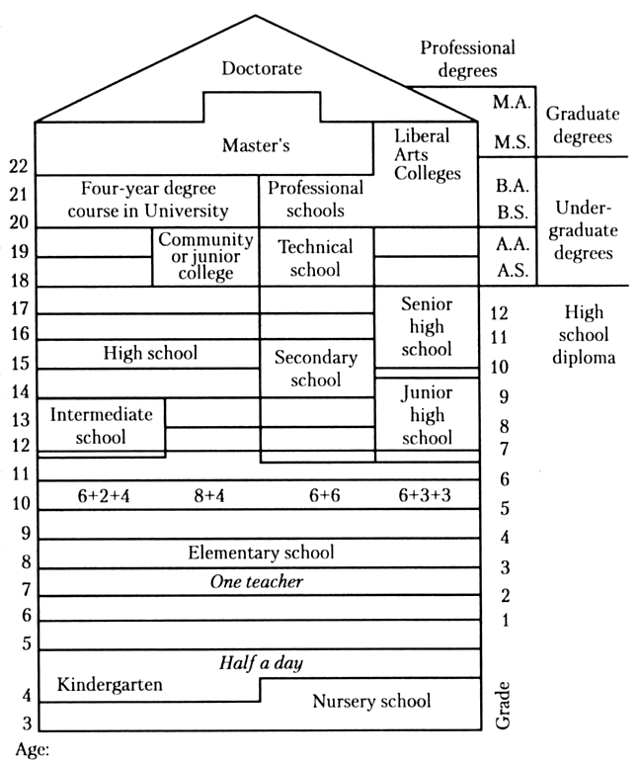

The Master's degree — programs leading to the degree usually require 1 or 2 years of advanced study in graduate-level courses and seminars. Frequently a thesis is required or a final oral or written examination. (M.A. — the Master of Arts, etc.)
The Doctor's degree — usually the Doctor of Philosophy (Ph.D.) (equal to the Russian candidate of Science, Philology, etc.) — the highest academic degree, it requires a minimum of 2 years of course work beyond the Master's degree level, success in a qualifying examination, proficiency мастерство in one or two foreign languages and/or in a research tool (such as statistics) and completion of a doctoral dissertation.

9. SAT — the Scholastic Aptitude Test проверка способности (in mathematics and verbal ability) used since 1947: 1600 scores — a good result; 400 scores — poor.
The SAT is taken in the 11th grade of high school. (About 1,5 million students take it yearly.)
Many educators point out that SAT scores are related to family income — the higher the income, the higher the SAT scores and certain minorities have not scored well because of low incomes and bad schools. SAT can be taken two or three times (in the 11th and 12th grades), generally proceeded by PSAT (preliminary), a test to give students a warm-up exercise for the SAT and indicate their probable SAT scoring range.
ACT — the American College Testing program — is similar to SAT but scores social studies and the natural studies. The ACT is taken when required by certain colleges or universities. (About 200,000 students take this test yearly.)
Both tests are widely used in the admission process of US colleges and universities. Their results are sent to the colleges or universities to which the students have applied. ACT is meant to be taken only once.
Achievement tests — special tests in a discipline required by some colleges for admission.

10. Academic Year is usually nine months duration, or two semesters of four and a half months each. Classes usually begin in September and end in July. There are summer classes for those who want to improve the grades or take up additional courses.
During one term or semester, a student will study, concurrently одновременно, four or five different subjects. The students' progress is often assessed through quizzes (short oral or written tests), term papers and a final examination in each course. Each part of a student's work in a course is given a mark which helps to determine his final grade. A student's record consists of his grade in each course.
College grades, determined by each instructor on the basis of class work and examinations, are usually on a five-point scale, with letters to indicate the levels of achievement. A — is the highest mark, indicating superior accomplishment исполнение, and the letters go through B, C, D to E or F which denotes failure. Many schools assign points for each grade (A = 5, B = 4, etc.) so that GPA (grade point average) may be computed подсчитывать. Normally, a minimum grade point average (3.5 points) is required to continue in school and to graduate.

11. Student Financial Aid — sums of money for students who need financial aid to attend college.
When a family applies for aid, an analysis is made of the parents' income; Financial Aid is normally awarded as part of a package комплект: part grant (a grant needn't be repaid, parts of which might come from several sources: federal, state, private scholarship стипендия, college scholarship); part loan (to be repaid after college); part work (colleges normally expect students on aid to earn some of the money they need by working summers on the campus).

12. Students Union. There are several national nongovernmental associations of students. The largest and most active has been the United States National Student Association, with headquarters in Washington, D.C. (USNSA).
A great deal of the cultural and recreational life at a university is created and conducted by student groups. They sponsor or participate in concerts, plays, debates, forums and festivals. They have various clubs, film societies, jazz groups, newspapers, magazines, radio stations, athletic events. At many universities, the centre of these social and cultural out-of-class activities is the Students Union. Some community colleges местный ("общинный") колледж or universities maintain major resident facilities услуги, fraternity студенческий клуб and sorority университетский женский клуб houses, and students unions.
There are also a large number of national fraternities and sororities with chapters (branches) at almost 500 colleges and universities. These organizations, Greek letter societies, are descendants of the 18th century library and social clubs which nourished in the early American colleges.
No society has more than one chapter филиал in any one college. While those societies are secret in character there is seldom any overemphasis чрезмерное подчеркивание of ritual or mystery in their conduct. The Greek alphabet is generally used in naming the fraternity, sorority or a chapter. It has become quite the practice for students of a particular fraternity to reside together during their college course in their "chapter" house. Students who live outside the colleges or universities live in cooperatives (cooperative housing associations providing lodgings), rooming houses or apartment complexes.

BRITISH AND AMERICAN UNIVERSITIES

British and American universities are similar in their pursuit стремление of knowledge as a goal but are quite different in their organization and operation.
English universities and colleges, because of their selective intake прием, are relatively small. American universities, which combine a number of different colleges and professional schools, are large, sometimes with 20,000 to 25,000 students on one campus. Teacher training colleges and polytechnics are alternatives to the university course for some students in England, being established for specific purposes. In contrast, virtually all schools of education, engineering and business studies, are integral parts of universities in the United States. In England universities receive about 70% of their financial support through Parliamentary grants. Similarly, in the United States, public institutions receive about 75% of their funds from local, state, and federal sources, but private colleges and universities receive little or no government support. In England, personal financial aid is provided by the government to over 80% of the students through local educational authorities according to the parents' income. In the US student's aid is administered by the university or the sponsoring agency and is provided by private organizations and the state or federal governments. Obviously British and American universities have similar educational aims but different means of achieving those aims.

Standardized Aptitude Test, SAT, тест на проверку академических способностей (необходим при поступлении в вузы США и Канады; оценивает общее знание литературы, истории и математики; различают два уровня тестирования: проверка базовых знания по математике и английскому языку и тесты по различным академическим дисциплинам)
отборочный тест. Экзамен по будущей специальности. В отличие от теста на обучаемость [SAT] определяет уровень знаний выпускников школ в конкретной области (часто в области предполагаемой специализации в университете)
"Тест американского колледжа". Один из тестов в системе тестирования студентов при поступлении в университет или переходе из одного университета в другой. Определяет общий образовательный уровень абитуриентов по английскому языку, математике, гуманитарным и естественным наукам. Число баллов - от 1 до 36. Ежегодно этот тест проходят около 1,2 млн. человек.
заведующий коммерческой частью

