Family Problems

Family problems come in all shapes and sizes; some are short-lived and easily managed, while others are more chronic and difficult to handle. Stress points include events such as illness and injury, changing jobs, changing schools, moving and financial difficulties.
Each family develops its own ways of coping with these stresses, some of which work better than others. Unsuccessful coping can be recognized by a number of characteristics, including the following:

Poor Communication
Family members either avoid talking with one another, or have not learned how to listen well to what others are trying to say through their words, expressions or actions.

Inability to Resolve Conflicts and Disagreements
This usually occurs because family members avoid discussing problems or even avoid admitting that problems exist. This allows the conflicts to continue - which, while causing some discomfort and unhappiness, allows the family to avoid what they see as the greater discomfort of facing the problem. Some families just have not learned the skills of negotiating or, for some other reason, cannot let go of bad or hurt feelings. Children are likely to pattern their behavior after their parents' behavior and may learn to refuse to talk about feelings and problems.

Poor Problem-Solving
Family members have trouble deciding what problems really exist, who is responsible, the options for solving them, and how the family can agree upon an option and act upon it. There may not be agreement on what the priorities are within the family.

Poor Division of Responsibilities
Families often have not decided how family responsibilities will be divided among family members. When that happens, family life can become chaotic, and many things do not get accomplished (законченный). At the other extreme, some families are not flexible at all, and family members do not help one another out or fairly reassign (перераспределять) responsibilities as family circumstances change.

Insufficient Emotional Support
Families are, especially for children, the most important source of emotional support. During the middle years, children find it hard to obtain this emotional support outside the family. Children do not perform or develop well without this support.

Intolerance of Differences
Families function best when the individuality of each family member is acknowledged and appreciated. At the least, even if someone else's personal traits or characteristics are not highly valued, each family member needs to tolerate these traits and respect that individual. When family members withhold (сдерживать) love from one another because of personal differences, children are likely to have a difficult time developing a healthy self-image, and they will have low self-esteem and poor social skills.

Overdependency on Others
Children need to succeed in order to feel capable of successfully managing life's stresses and challenges. If they are taught or encouraged to depend on others (within the family or outside it) to solve their problems, they will have low self-esteem and limited initiative and will have trouble succeeding in the world.

Chronic Crises
Families who have some of the above characteristics are likely to have trouble coping with life's inevitable crises. In these families even relatively simple problems are not resolved but take on the appearance and feel of major dilemmas. Thus, by their lack of successful coping skills, these families create additional problems for themselves and go from crisis to crisis, with little relief and little pleasure from life or from one another.

Although we all strive for perfection, there is no perfect family. Each family has its own strengths and weaknesses, assets and liabilities, challenges and problems. If your family seems overwhelmed with problems, or if there is a breakdown in relationships within your family, it is probably time for outside help.
As a parent, your task is to meet the multiple demands of family life with energy and creativity. By doing so, you will enable your children to grow and develop in positive, healthy ways and to experience satisfaction and success.

Excerpted from "Caring for Your School-Age Child: Ages 5-12" Bantam 1999

Accommodation. Houses in England

Most people in England live in urban areas. Towns and cities are spreading into their surrounding environment to cope with the increase populations. In England, an average of 7,000 hectares of farmland, countryside and green space were converted to urban use every year between 1985 and 1998. This is almost the equivalent size of 9,600 international football pitches!

Who owns houses in England?
More people are buying their own homes than in the past. About two thirds of the people in England and the rest of Britain either own, or are in the process of buying, their own home. Most others live in houses or flats that they rent from a private landlord, the local council, or housing association.
People buying their property almost always pay for it with a special loan called a mortgage (заклад), which they must repay, with interest, over a long period of time, usually 25 years.

What are houses in England like?
Most houses in England are made of stone or brick from the local area where the houses are built. The colours of the stones and bricks vary across the country.

Types of houses in England
England has many types of homes. In the large cities, people often live in apartments, which are called flats. In most towns, there are streets of houses joined together in long rows. They are called terraced houses.
The main types of houses in England are:
Detached (a house not joined to another house)
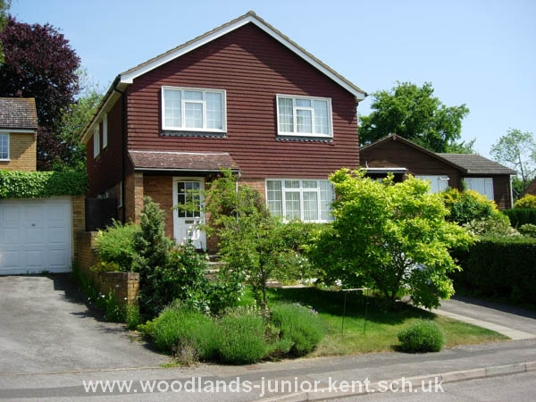
Semi-detached (two houses joined together)
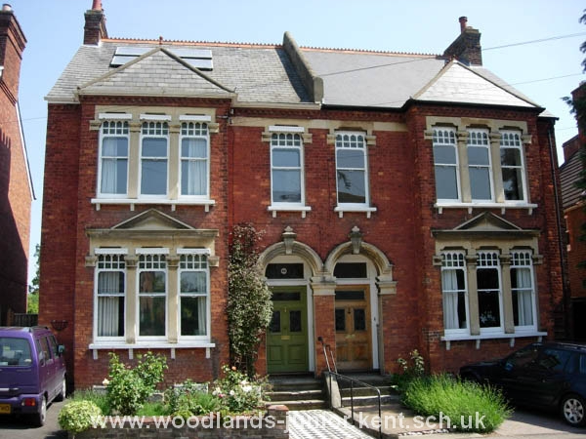
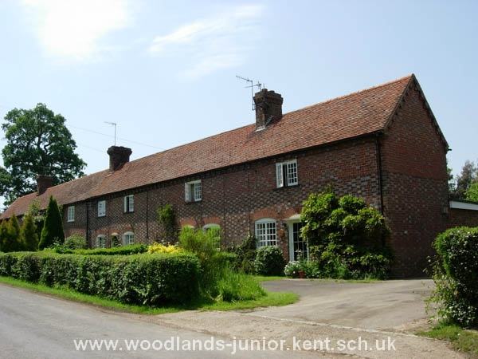
Terrace (several houses joined together)

Flats (apartments)
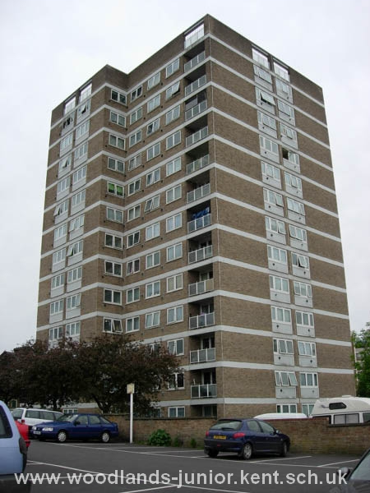
The most popular type of home in England is semi-detached (more than 27% of all homes), closely followed by detached then terraced.
Almost half of London's households are flats, maisonettes or apartments.

Cost of Houses
A big problem in England is the rising cost of houses. In 1989 first-time buyers paid an average of around £40,000, but by 2001 this had more than doubled to £85,000. Research by Halifax shows that there is no town in Britain where average property prices are currently below £100 000.
Greater-London is topping the table for the highest average prices, which are likely to push through the £300 000 barrier in the third quarter of the year.
The cost of housing in England has increased much faster than people's wages making it impossible for first-time buyers to get on the housing ladder unless they are in especially well-paid jobs, are able to call upon rich relatives or are prepared to buy jointly with friends.

