CULTURE SPOT

National symbols

Countries often have national symbols or emblems. Britain is usually shown as a lion or a bulldog. The USA has an eagle as its symbol. Australia uses a kangaroo.

Countries have their own national colours, too. These are usually the colours of the national flag. The patriotic colours in Britain and the USA are red, white and blue. Companies and political parties often use these colours to create a feeling of national pride.

The different parts of Britain have their own emblems, too. They are all plants. You can see them on pound coins.

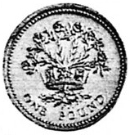 | 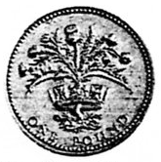 | 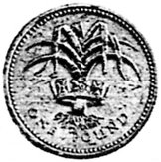
England has the rose. | Scotland has the thistle. | Wales has the leek.

In the fifteenth century there was a long series of wars in England, which was called the Wars of the Roses. It was fought between the Dukes of Lancaster and the Dukes of York over who should be king. The emblem of Lancaster was the red rose and the emblem of York was the white rose. Eventually the Duke of Lancaster won, so the rose in the English emblem is the red rose.

Each country has its own colour, too. These are used, for example, for football or rugby teams. The colours for the different parts of Britain are:

England white | Scotland blue | Wales red

These colours come from the national flags. The English flag is white with a red cross. The Scottish flag has a white cross on a blue background. The Welsh flag shows a red dragon.

COMPARISON

- What national emblems and colours does your country have?
- Do different parts of the country have their own emblems, flags and colours, too?
- What do you know about the origins of the symbols and colours?

